What Jobs Can Our Eyes Do?
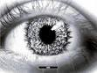
In each cloud write something your eyes can do.

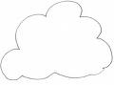

© 2007 Association for the Blind of Western Australia
Exceptions: Image
© Microsoft Office Clip Art

